# **Digital Archival Tracker – Application Walkthrough**

The Digital Archival tracker aims at replacing the regular spreadsheet with a responsive UI that enables tracking of AIP Records from AIP Excel sheet that features adding, updating and deleting AIP records along with displaying Fixity report data in a concise and structured manner. This report mentions all the features that are currently present in the application.

As the application evolves more features will be added which will increase user convenience and productivity. The application currently reads limited number of columns from the AIP Excel sheet for the purposes of the demo. Adding the remaining columns and giving the user the option to add custom columns will be implemented in the coming weeks.

The application process is explained in detail in the following steps:

**AIP Excel Sheet**

**Step – 1: Loading AIP Excel sheet to create database and tables.**

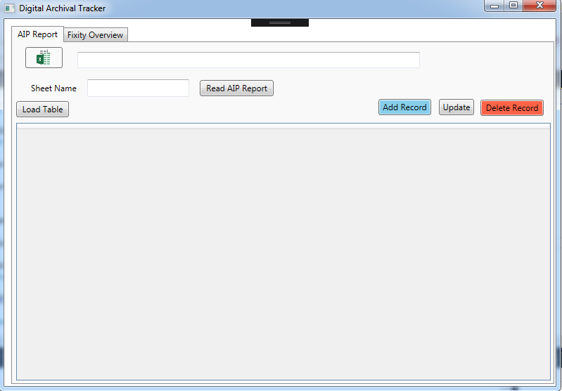This is the first step that needs to be performed when the application is running on a new machine for the first time and doesn’t have a database. When the AIP Excel sheet is uploaded by the user, the application creates a new database with a table that has the default columns as per the Excel sheet.

The following screenshots illustrates the UI of the Digital Archival Tracker and the walkthrough to load an Excel sheet from the machine as follows.

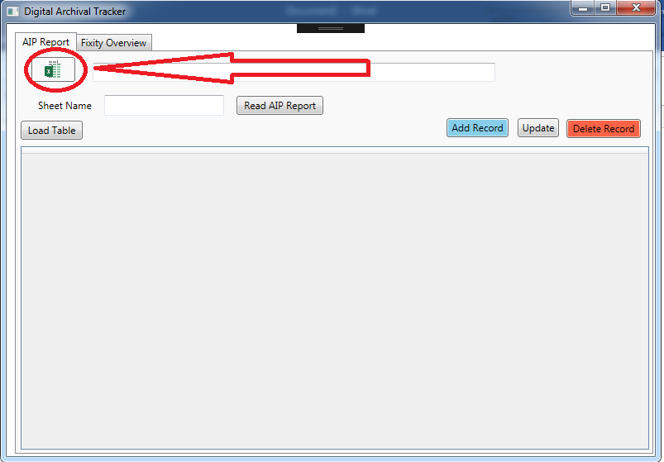Press the Excel icon button C:\Mine\GDP Final Project\Walkthrough Beta\2.png to browse for the Excel Sheet. This opens a window which allows the user to select an Excel file to upload from the file system.

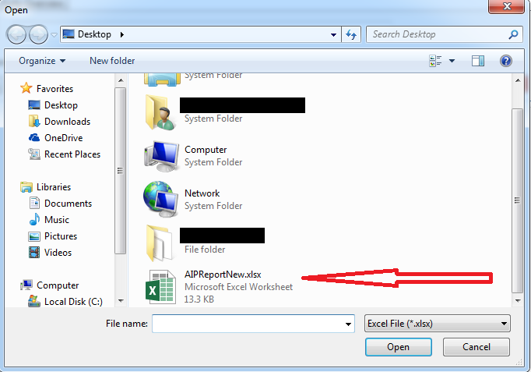An example file “**AIPReportNew.xlsx**” is shown below.

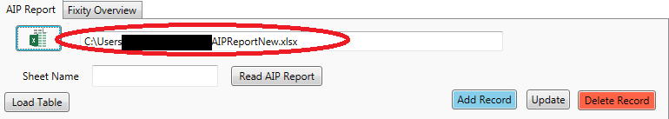This uploads the file and fills the text box beside the Excel button with the path of the Excel file chosen for confirmation.

**Next**, the name for the Excel sheet is to be entered in the text box “**Sheet Name**”, then press the “**Read AIP Report**” button to read the Excel sheet uploaded.

This button also enables the application to check if a database already exists. if we are working with the application for the first time this button triggers the function that creates a new database and enters the Excel sheet into the database.

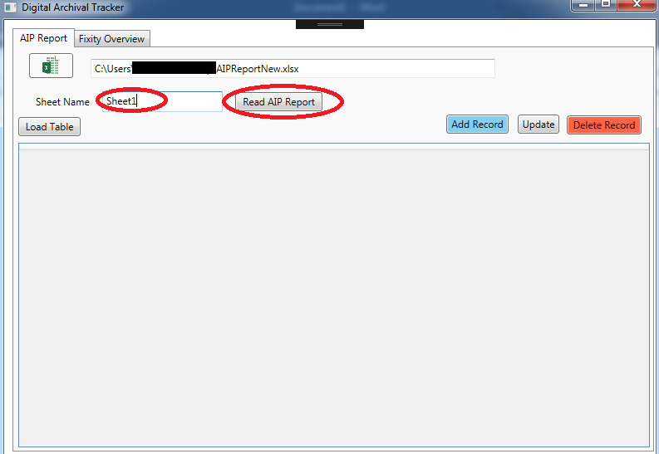

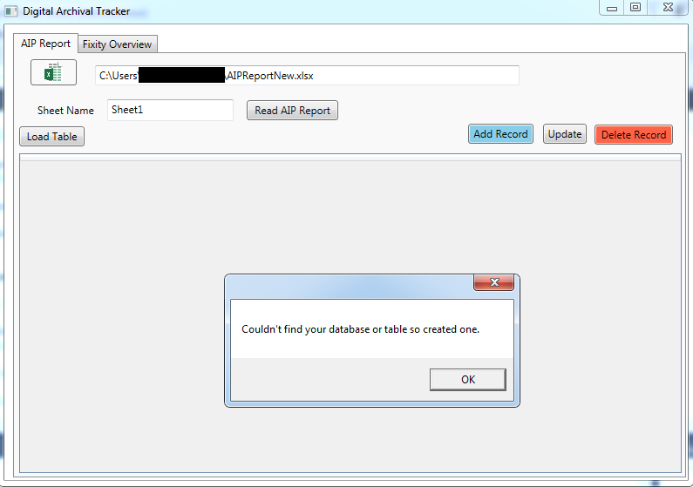

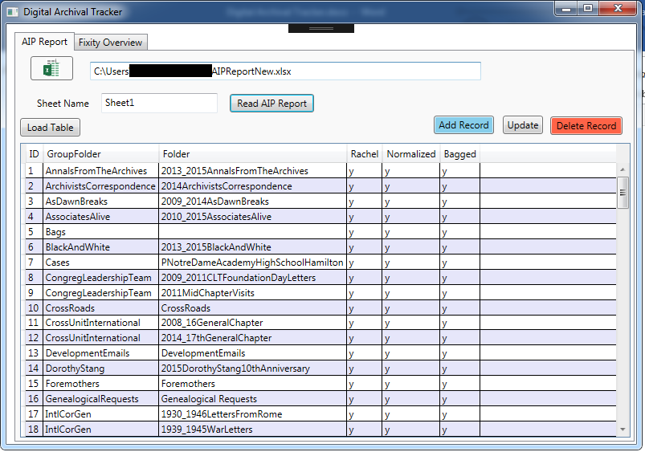Once the database is created the data is populated in the data grid.

**NOTE**: The ID column here was manually added beforehand to the AIP Excel file which was selected. But in the future versions no such task would be necessary because the IDs will be generated automatically and maintained internally. We may show the ID column because the database requires at least one column to have unique values. We couldn’t use Group Folder or Folder columns because both contained repeated values, hence the introduction of ID column.

**Step 2: Creating, Updating & Deleting an AIP Record**

**Creating**:

The “**Add Record**” button creates a record in the data grid which is saved into the database.

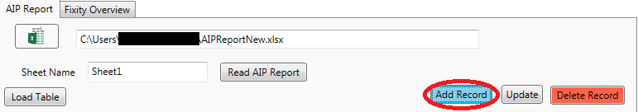

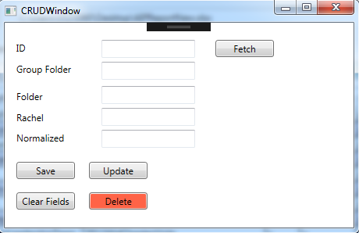When the user clicks on the button a CRUD (Create, Retrieve, Update, Window) window is opened which gives the user the option to add an AIP Record.

The function of all the buttons in this window is as follows:

* **Fetch**:

An AIP Record value can be fetched using the “**Fetch**” button. When an ID is entered in the textbox next to the “**ID**” label the “**Fetch**” button searches the database for that specific value and the rest of the values are then populated.

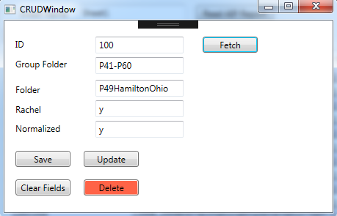

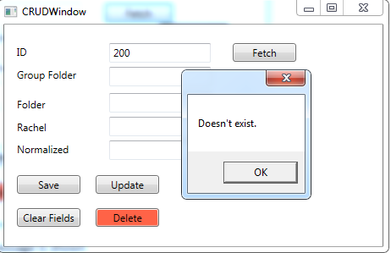If no record with the mentioned ID is found an error message is shown. For now, the application keeps track of IDs but in the future, we will generate IDs automatically and it won’t be necessary to type in ID when you create a new AIP record.

* **Clear Fields**:

All the text fields which are populated with data when “**Fetch**” is clicked or data is entered manually is cleared when this button is clicked.

* **Save**:

This button saves the values in the data grid after all the text fields are entered.

* **Update**:

See upcoming section for details.

* **Delete**:

See upcoming section for details.

**Updating**:

The button “**Update**” on the Main Window and the button “**Update**” on the CRUD Window perform the same operation of updating an AIP Record in the database.

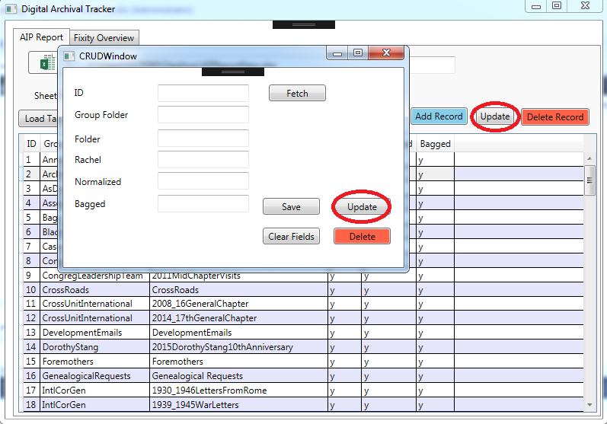

To update a record from the Main window, select the desired record and press “**Update**” a window with all the data of the selected record prepopulated is shown which can be edited.

**Note**: This window contains all the buttons “**Fetch**”, “**Clear Fields**”, “**Save**”, “**Update**”, “**Delete**” described in the previous section.

**Deleting**:

The button “**Delete Record**” on the main window and the button “**Delete**” on the CRUD Window also perform the same operation of deleting an AIP Record from the database.

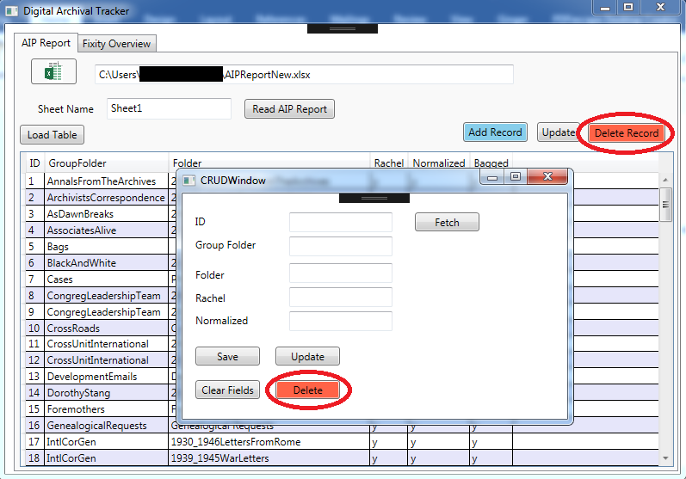

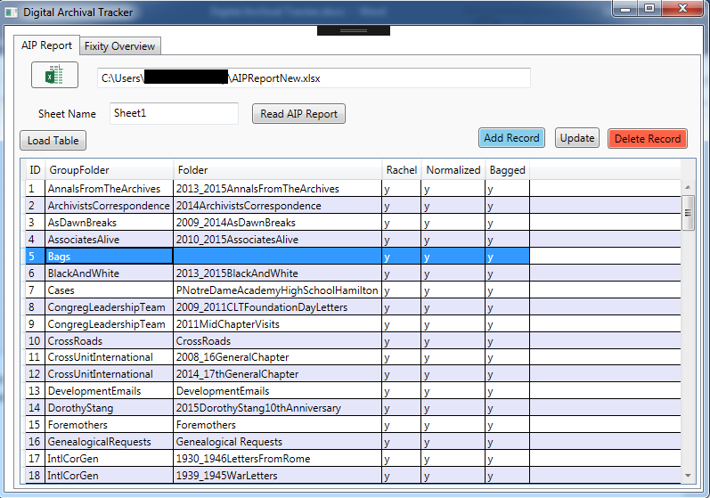To delete a record from Main Window just select the desired record and click the “**Delete Record**” button.

**Step – 3: Loading a table from existing database**

After the first run, the database exists and if we want to load the AIP table from an existing database, click on the “**Load Table**” button. This checks if the database exists and loads the table from the database into the UI.

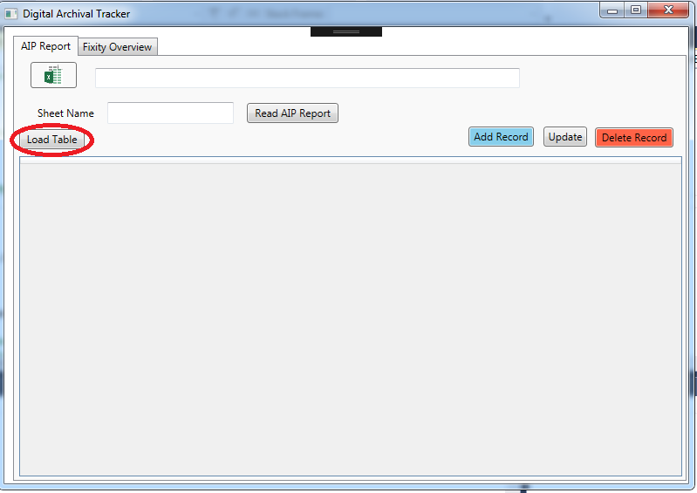

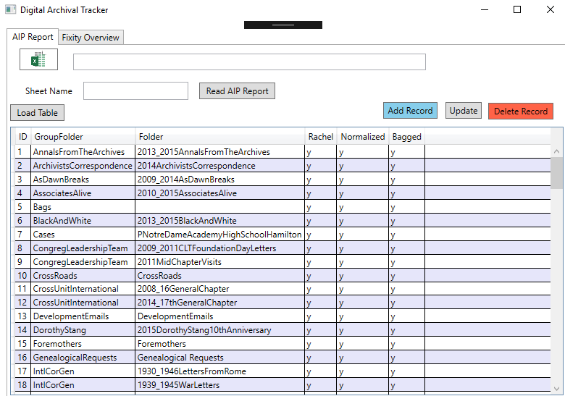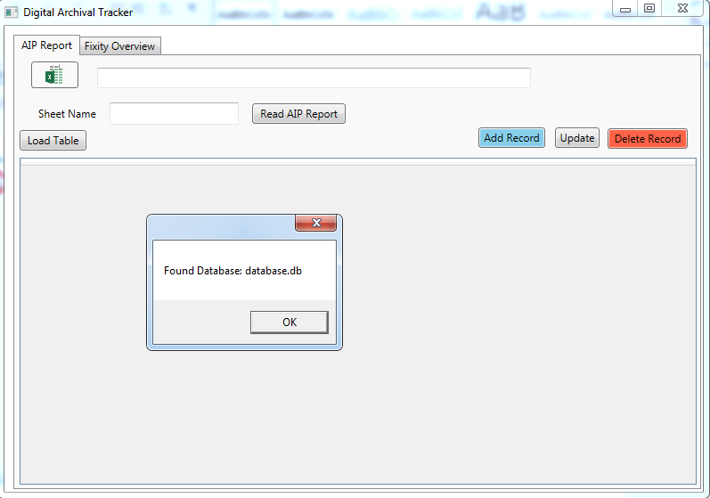

**Reading Fixity Report**

Reading Fixity reports from a folder is one of the other primary requirements requested for Digital Archival Tracker. The application has tabs which the user can easily switch between. The **AIP Report** tab hosts all the features mentioned earlier and the **Fixity Overview** tab presents data read from Fixity reports.

The application process is explained in the following steps:

**Step – 1: Loading Fixity Report Folder.**

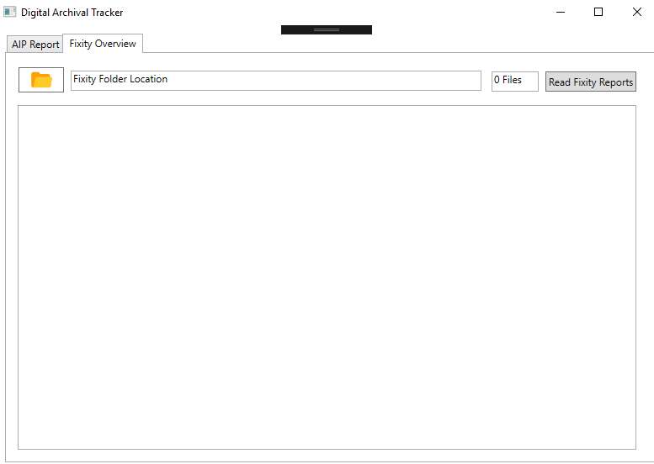First, click on **Fixity Overview** tab to switch.

Then click on the Folder icon to select where the Fixity reports are located. A window pops up which will allow you to select the Fixity Report folder.

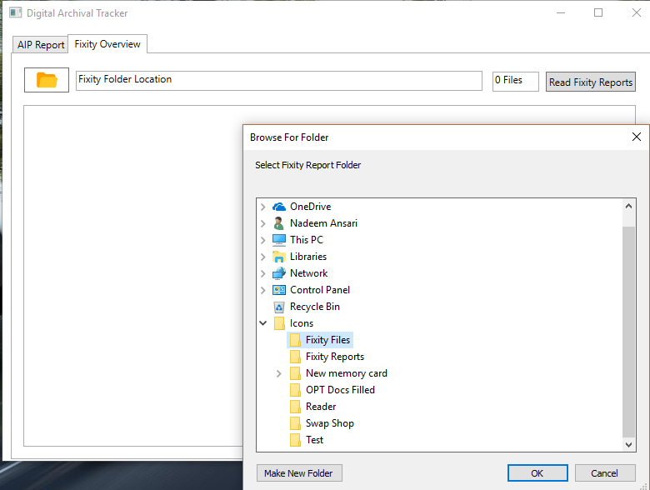

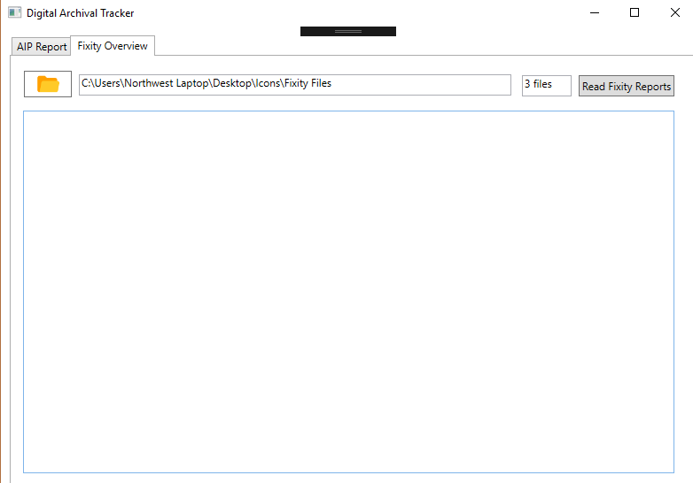Select the folder and the application will load the folder path in the **Fixity Folder Location** box. The number of Fixity report files found in that folder will also be displayed right beside it.

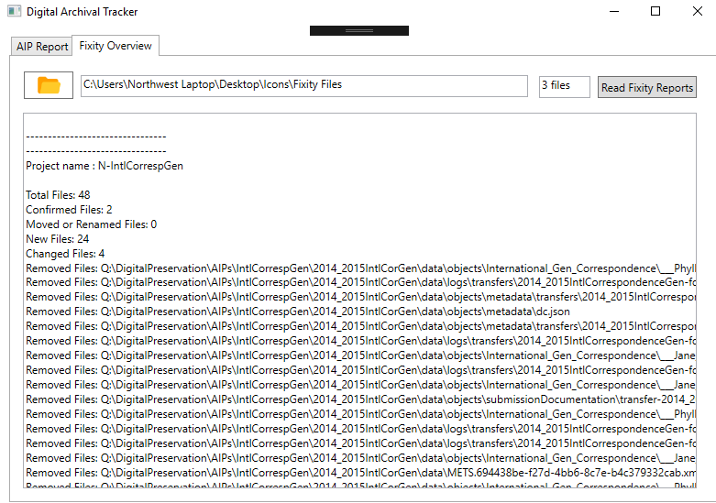Click on “**Read Fixity Reports**” button on the top right corner to read the Fixity reports present in the folder. As of now, the application presents the Fixity report data in the box below as shown. We are working on implementing a design that is a lot more efficient in performance and usability and we will be able to present that and other promised features for **AIP Report** tab in the upcoming demo and meetings.

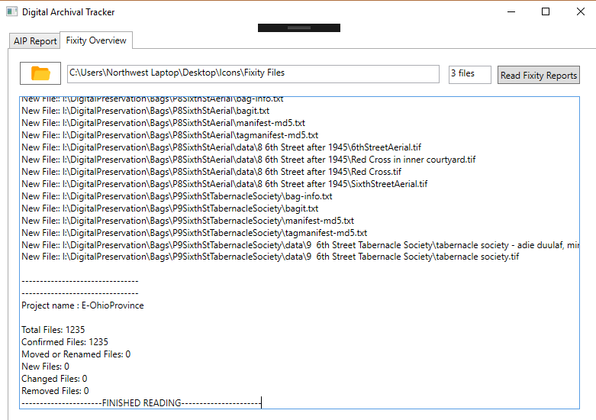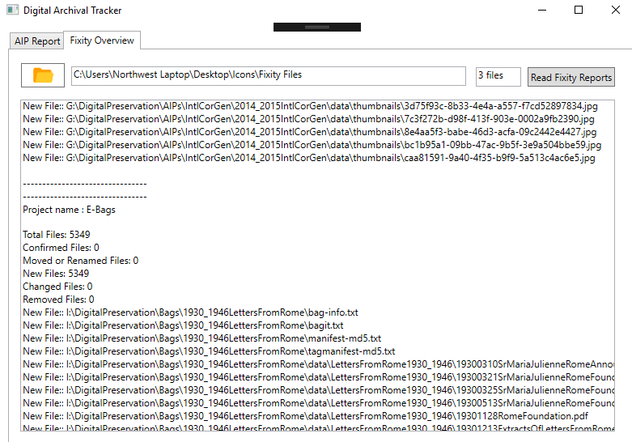

**Summary**

Finally, Digital Archival Tracker started with solid requirements and we went on the design the prototypes and implementing them this semester. We can read AIP Excel sheets and we will make them dynamic in the sense that the application will be able to read any number of columns already present in the AIP Excel sheet along with providing the ability to the user to add and remove as many columns as desired. The application will also not ask the user to provide ID values as these will be maintained internally by the database in the future versions. For the **Fixity Overview** tab, the data read will be presented in a clear and understandable manner for a quick overview.